Engine Coolant Temperature Gauge – PHEV_FHEV – CGEA 1.3

Functional Description

The purpose of the Engine Coolant Gauge feature is to inform the driver of the vehicle’s engine coolant temperature.

The Engine Coolant Gauge correlates the EngClnt_Te_Actl, EngClntTe_D_Qf, EngOvrhtMitgActv_D_Ind, and HvacHtrCore_Te_Actl signals and the Operational Mode to generate pointer movement displaying the vehicle’s engine coolant temperature in Cold, Normal and Hot regions.

A PHEV is unique from other vehicles since it uses signal HvacHtrCore2_Te_Actl. This is because it is possible to drive a PHEV several miles on only the electric motor without ever starting the gasoline engine. In that case, the coolant does not circulate through the gas motor, so HvacHtrCore2_Te_Actl is important to show the vehicle has warmed up and heat is available to the HVAC system (PHEVs have a 3-way valve to allow cabin heating in electric vehicle mode and to use engine heat opportunistically). This signal has to be used for the engine overtemp warning as well to protect for a use case where the HCIV fails in the PTC HTR loop. In this mode, the engine and PTC loops are completely independent, and so looking at the two signals gives us observability and if any of the two rise above the threshold, so the telltale would display. Although this signal is unique for PHEV, this STSS applies to both FHEV and PHEV. (On an FHEV, HvacHtrCore2_Te_Actl is set equal to EngClnt_Te_Actl.)

Based on PT_Hyb_Cfg2, if vehicle is not a hybrid, use Engine Coolant Temperature Gauge – CGEA1.3 STSS.

The Engine Coolant Gauge shall be capable of indicating the maximum engine coolant temperature. The raw input temperature from the BCM is filtered by the cluster for smooth and continuous pointer movement. A "flat response" shall be implemented in the Normal operating region.

The Engine Coolant Gauge shall provide an analog gauge fill display with a moving colored fill to indicate the vehicle’s engine coolant temperature. The Engine Coolant Gauge fill shall increase from bottom to top to register increasing engine coolant temperature and decrease in the opposite direction for decreasing engine coolant temperature.

Interfaces

Interface Context Diagram (I/O Block Diagram)

Engine Coolant Temperature Gauge Context Diagram

Inputs

IR-REQ-312274/B-Internal:

- Operational_Mode

MUX messages

Input Signals

SIG-REQ-312259/A-EngClnt_Te_Actl Signal

Signal Name | Size  (bits) | Detail | Units | Res. | Offset | State Encoded | Min. | Max.
EngClnt_Te_Actl | 8 |  | deg C | 1 | -60 |  | -60  (0x0) | 195  (0xFF)

SIG-REQ-312260/A-EngClntTe_D_Qf Signal

Signal Name | Size  (bits) | Detail | Units | Res. | Offset | State Encoded | Min. | Max.
EngClntTe_D_Qf | 2 |  | SED | 1 | 0 |  | 0 (0x0) | 3 (0x3)
 |  | Faulty |  |  |  | 0x0
 |  | No_Data_Exists |  |  |  | 0x1
 |  | Not_Within_  Specifications |  |  |  | 0x2
 |  | OK |  |  |  | 0x3

SIG-REQ-312261/A-EngOvrhtMitgActv_D_Ind Signal

Signal Name | Size  (bits) | Detail | Units | Res. | Offset | State Encoded | Min. | Max.
EngOvrhtMitgActv_D_Ind | 2 | Normal_mode | SED | 1 | 0 | 0x0 | 0 (0x0) | 3 (0x3)
 |  | Mode 1 |  |  |  | 0x1
 |  | Mode 2 |  |  |  | 0x2
 |  | Undefined |  |  |  | 0x3

SIG-REQ-312262/A-HvacHtrCore2_Te_Actl Signal

Signal Name | Size  (bits) | Detail | Units | Res. | Offset | State Encoded | Min. | Max.
HvacHtrCore2_Te_Actl | 10 |  | deg C | 0.25 | -50 |  | -50  (0x000) | 205.5  (0x3FF)
 |  | Faulty |  |  |  | 0x3FF

Outputs

IR-REQ-312275/A-Internal:

Engine Coolant Temperature Gauge Indication

Function/Performance

F-REQ-312279/A-Operational Modes

Mode | Differentiating Vehicle Conditions
Sleep Mode | Engine Coolant Temperature Gauge needle at “Rest Position”
Limited Mode | Engine Coolant Temperature Gauge needle at “Rest Position”
Normal Mode | Engine Coolant Temperature Gauge needle at “Engine Coolant Temperature Gauge”
Crank Mode | Engine Coolant Temperature Gauge needle at “Engine Coolant Temperature Gauge”

Voltage Levels

Refer to the Cluster Features table located in the Operational Modes and Voltage Range Strategies Section of this SPSS.

Human-Machine Interface

Visual

Indicator Graphics / Display Format
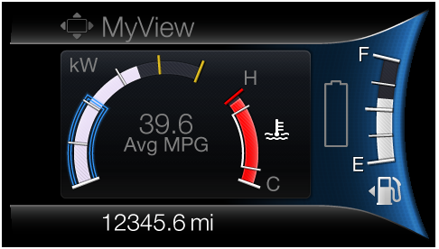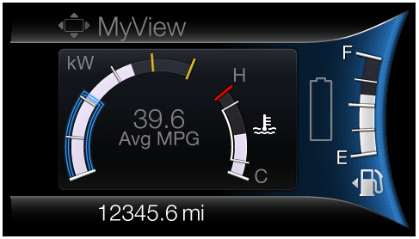
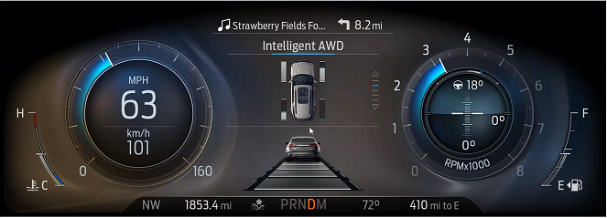

Note: Refer to the latest HMI files for the latest graphics.

Indicator Color Coordinates

None

Indicator Characteristics

None

Audio

None

Switch Control Logic

Not Applicable

System Accuracy

None

Operation: Performance and Functional

Subsystem Algorithm Flowchart / State Diagram

F-REQ-312269/B-Engine Coolant Temperature Update Flowchart

F-REQ-312270/A-Engine Coolant Temperature Pointer Update Flowchart

F-REQ-312272/A-ECT_Gauge_Fill_Color:

The Engine Coolant Gauge Fill Color turns Red at 121 ° C. Refer to the “ECT_PHEV_Engine” or “ECT_FHEV_Engine” tab in “Engine Coolant Temperature Transfer Function-CGEA1.3_vx.x.xls”
For < 121 ° C, the Gauge Fill Color is White.

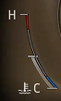

Operation Description (supports algorithm flowchart /state diagram)

F-REQ-312271/A-Gauge Pointer Rest Position

Gauge pointer shall move below the cold grad to "Rest Position" (see transfer function) at max rate when:
- The IC operational mode transitions to Limited Mode.
- Controlling signals are declared missing or invalid per the diagnostic section of this SPSS.
- Microprocessor executes a hardware reset.

F-REQ-312267/A-Input Temperature Data Processing

The raw inputs temperature are filtered by the cluster for smooth and continuous pointer movement.

F-REQ-312268/A-Gauge Pointer Traverse Time to Rest Position

The Engine Coolant Temperature Gauge shall traverse to the “Rest Position” within 1000 mS when in Limited Mode.

Engine Coolant Temperature Gauge Filtering

F-REQ-312264/A-Filter Rate Order

The Engine Coolant Temperature Gauge shall support a first-order filter rate that controls the filtering of rising and falling values.

F-REQ-312265/A-Initial Value

The Engine Coolant Temperature Gauge shall be initialized to the first valid signal (EngClnt_Te_Actl or HvacHtrCore_Te_Actl ) received after:
- A transition to Normal/Crank from Limited.
- A recovery from the "Rest Position" for missing or invalid messages

F-REQ-312266/A-Initial Filtering Rate

The recommended initial filtering rate is one degree C per second.

FS-REQ-312288/A;1-Function Safety Classification (EMC)

Class B

NVM-REQ-312276/A-Memory Storage

Parameter Name | Description | Value at  Battery Connect | Value at  Module Wake-up
Engine Coolant Temperature Gauge Indication | Used to control the gauge pointer position. | "Rest Position" | "Rest Position"
ECT_Icon_Color | Engine Coolant Icon Color ( White or Blue) | White | White
ECT_Gauge_Fill_Color | Engine Coolant Gauge Fill Color (White or Red) | White | White
EngClnt_Te_Actl Signal | CAN signal sent from the PCM for Engine Coolant Temperature | -60 (0x0) | -60 (0x0)
EngOvrhtMitgActv_D_Ind Signal | CAN signal sent from the PCM for Failsafe Cooling State. | 0 (0x0) | 0 (0x0)
EngClntTe_D_Qf | CAN signal sent from the PCM used to identify the quality factor of the EngClnt_Te_Actl signal. | 0 (0x0) | 1 (0x1)
HvacHtrCore_Te_Actl | CAN signal sent from the ACCM | -50 (0x0) | -50 (0x0)
Operational_Mode | 4 state indicator for cluster operational mode | Limited | Limited, Normal or Crank

Prove Out

No

Error Handling

SR-REQ-312289/A-Gauge Pointer in Error Condition

The Engine Coolant Temperature Gauge shall return to the “Rest Position” within 1000ms of determining an error condition.

Missing Message Strategy

The signals will be declared missing as per the Diagnostics section of this SPSS.

DTCs states and history will be determined as per the Diagnostics section of this SPSS.

Invalid Message Strategy

The signals will be declared invalid as per the Diagnostics section of this SPSS.

DTCs states and history will be determined as per the Diagnostics section of this SPSS.

Diagnostics

DIR-REQ-312280/A-Self Test

The gauge shall sweep the full range & return to the "Rest Position".

Engineering Test Mode

Reference section “Dealer / Engineering Test Mode (ETM)”

Part II Performance

DID-REQ-312277/A-Supported Diagnostic DIDs (Service $22 and $2F)

Number | PID / CommonID Name | DID Type | Comments
61B2 | Engine Temperature gauge pointer position | Numeric | % of gauge sweep (i.e., 0% = center of cold chaplet, 100% = center of hot chaplet; linearly interpolate in-between)

DTC-REQ-312278/A-Supported Diagnostic Trouble Codes (DTCs)

DTCs shall be logged as per the diagnostic section of this SPSS.

DTC | Description
C10000 | Lost Communication with ECM/PCM
C40100 | Invalid Data Received from ECM/PCM A Control Module
C40181 | Invalid Data Received from ECM/PCM A Control Module – Invalid Serial data

DCR-REQ-339202/A-DID DExx

Block  Num | Block Description | Byte(s) | Bits | State: Description | "0" | "1" | Default | Comments/  Information
$09 | Option Content (B&A) |  | 3 | PT Hybrid2(PT_Hyb_Cfg2)  0x0 = Non-Hybrid  0x1 = BEV  0x2 = FHEV  0x3 = PHEV  0x4 = MHEV |  |  | 0x0 | Default from cluster plant to be 0x0 if cluster can be used on a Non-Hybrid.

Reference Specification

None

Revision History
SPSS Module Revision History

Revision Level | Name | Change Description | Date
1.0 | SWatkins | Initial Release. (Based on Engine Coolant Temperature Gauge - 2012-3_PHEV_FHEV v1.2.doc and Engine Coolant Temperature Gauge - CGEA1.3_v2.2.doc). | 9/24/2016
1.1 | SWatkins | CAN signal HvacHtrCore_Te_Actl is now HvacHtrCore2_Te_Actl. | 9/28/2016
1.2 | HSharma | Functionality related to CAN signal EngOffTe_B_Dsply is removed. ECT Icon color shall not turn blue in any condition. However ECT Icon clor can turn red in Overheat condition based in program configuration(Dual use of Gauge Icon). | 6/04/2018
1.3 | A. Mishra | Initial VSEM RM Release | 8/02/2018
1.4 | H. Sharma | This change was brought to DICC by Angela Tasiopoulos (U625 D&R) 0n 10/02/2018 and approved offline for STSS update. The reason for changes is that ECT gauge is different between gas / FHEV and PHEV and U625 does not have a unique part number for PHEV variants so a configuration is required to configure the gauge. Changes are marked in Turquoise color.  - Functional Description updated.  - Section 1.2.1 is updated to add PT_Hyb_Cfg2 to make this gauge configurable if required.  - F_REQ-312269 is updated to add PT_Hyb_Cfg2 configuration.  - Section 1.5.3.3 is added to add DExx configuration details. | 01/10/2019

